1. | advantages of optical fiber over twisted-pair and coaxial cables  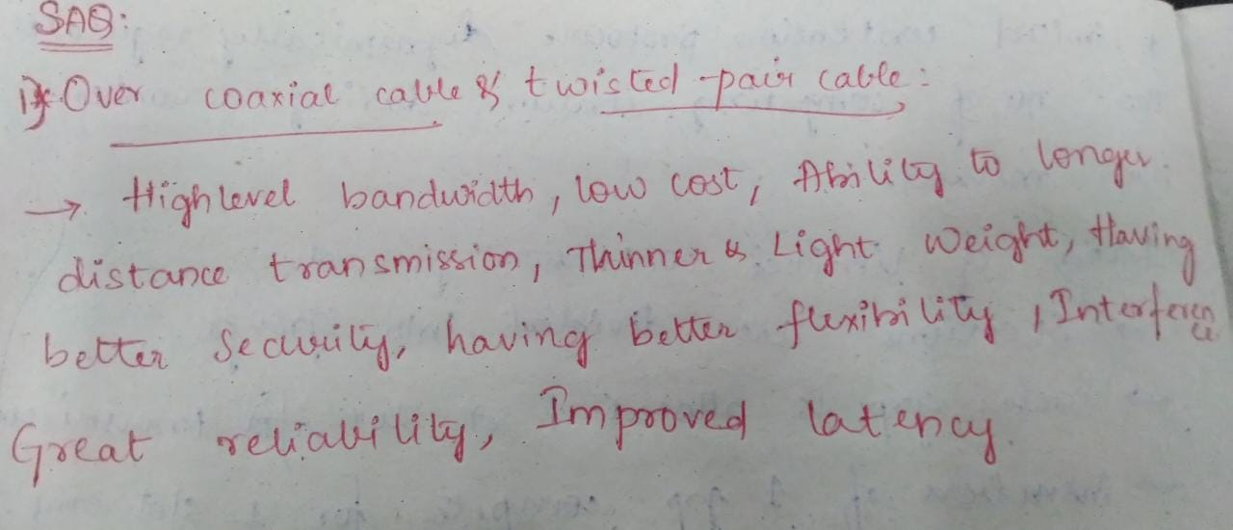
2 | advantages of having layered architecture?  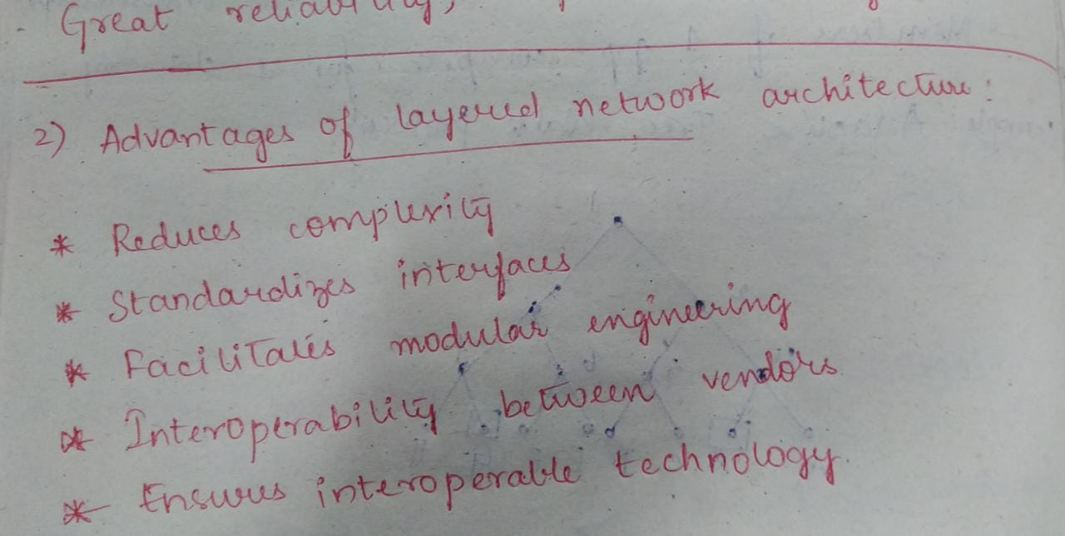
3 | design issues of data link layer.  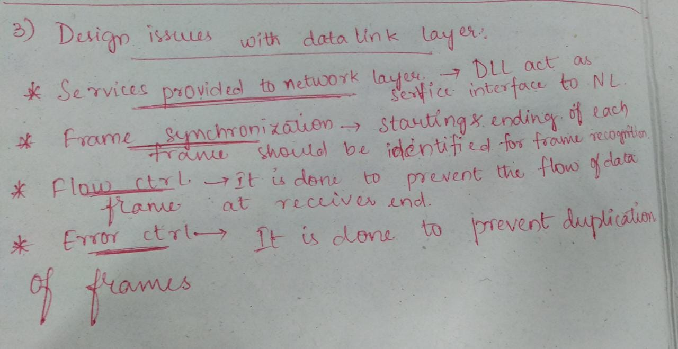
4 | Piggy Backing?  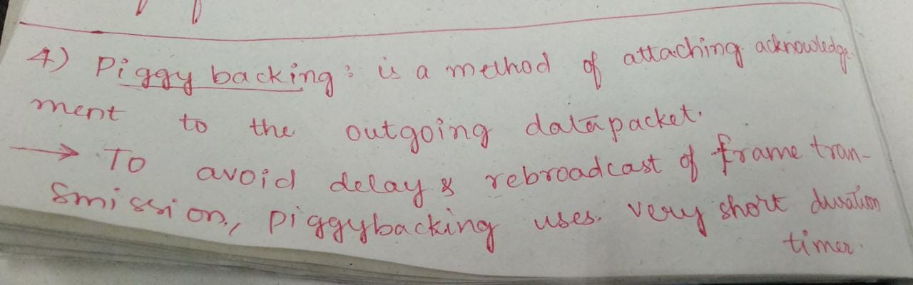  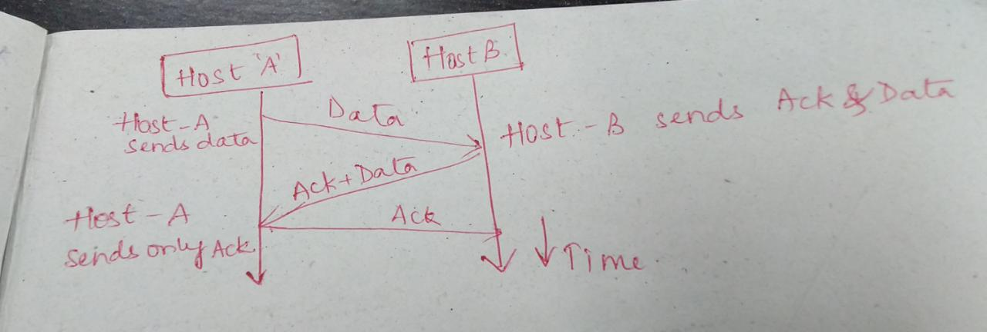
5 | multiple access protocols?  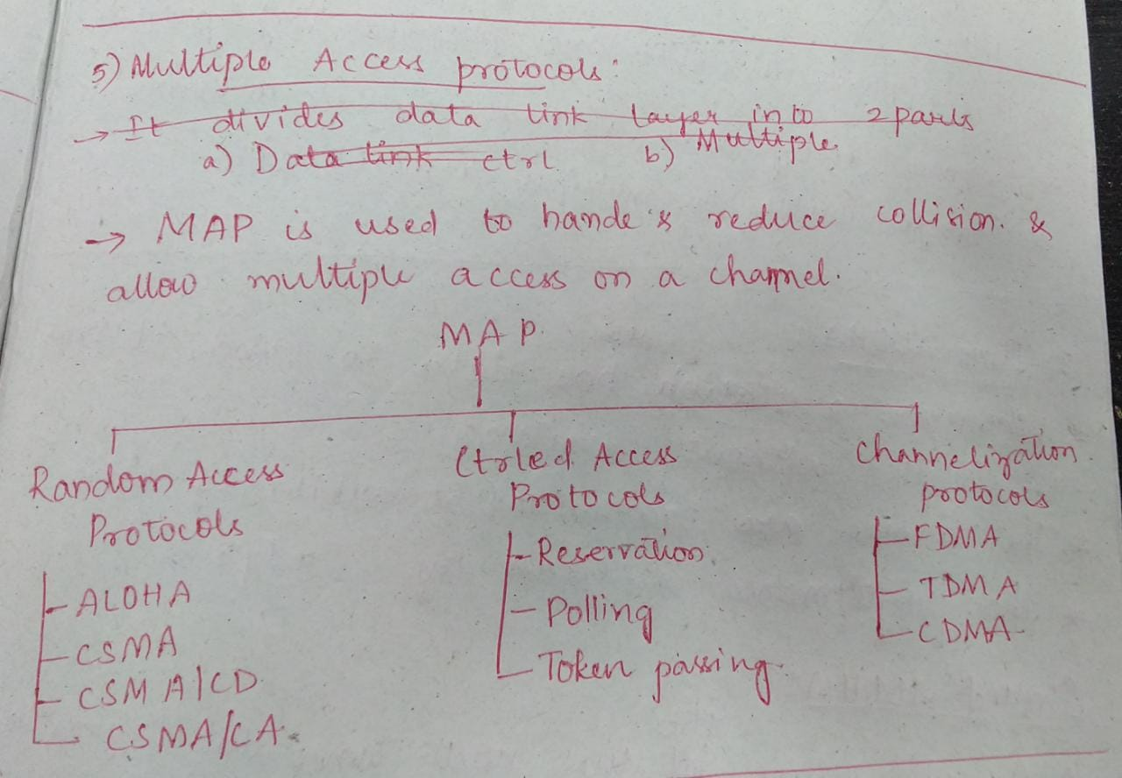

6 | Internet  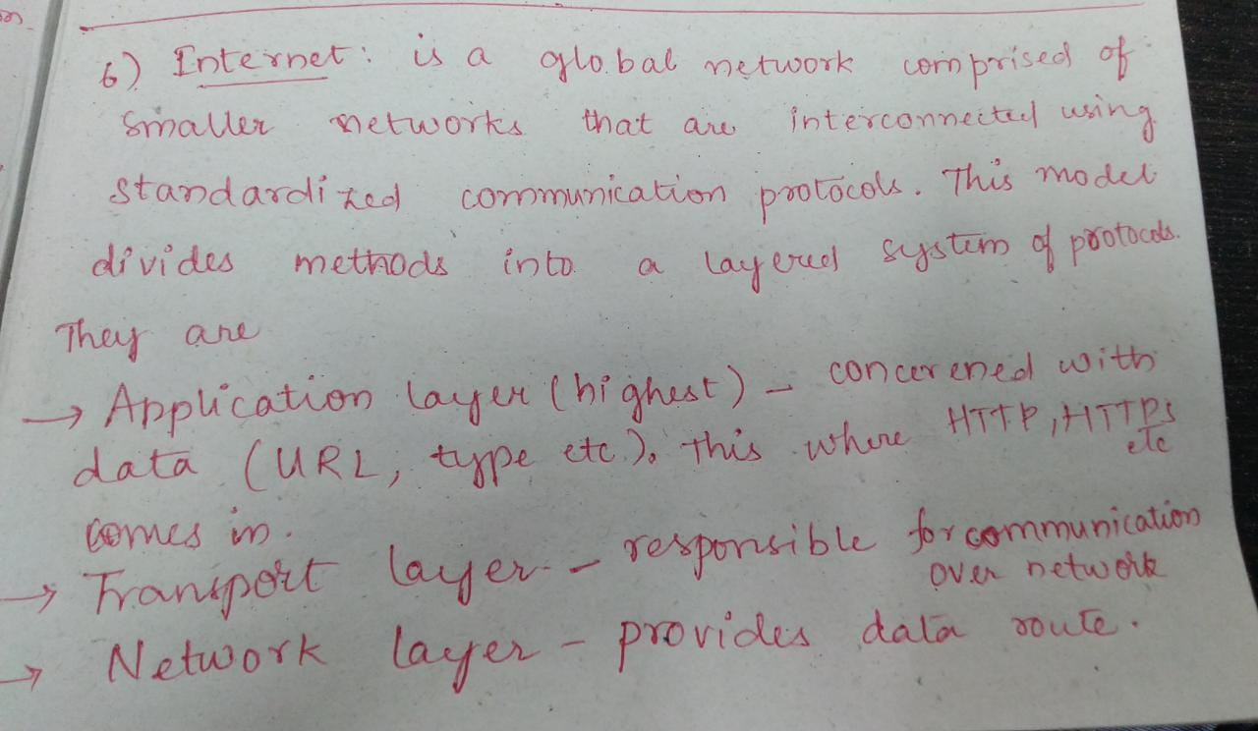
7 | Frame Relay?  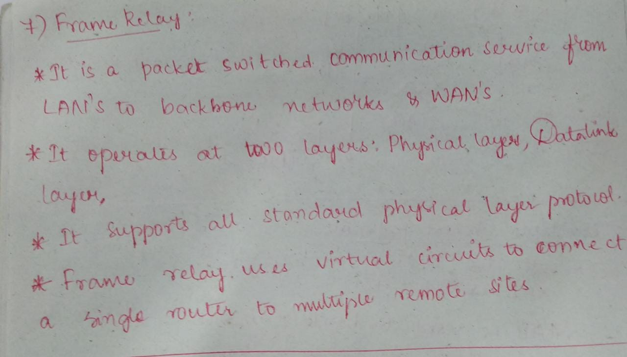
8 | Pure ALOHA and slotted ALOHA.  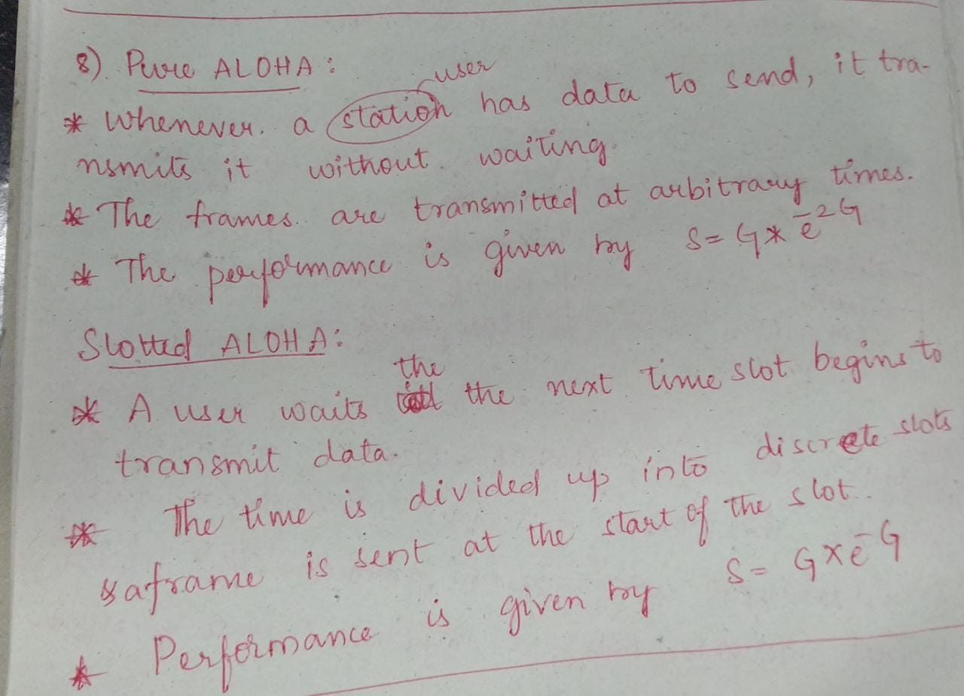
9 | Manchester Encoding.  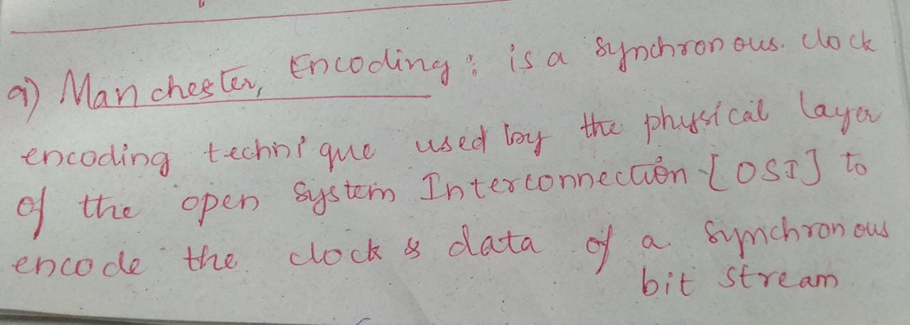  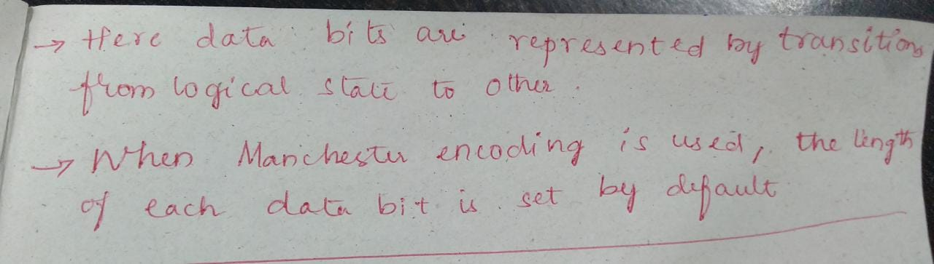
10 | Flooding?  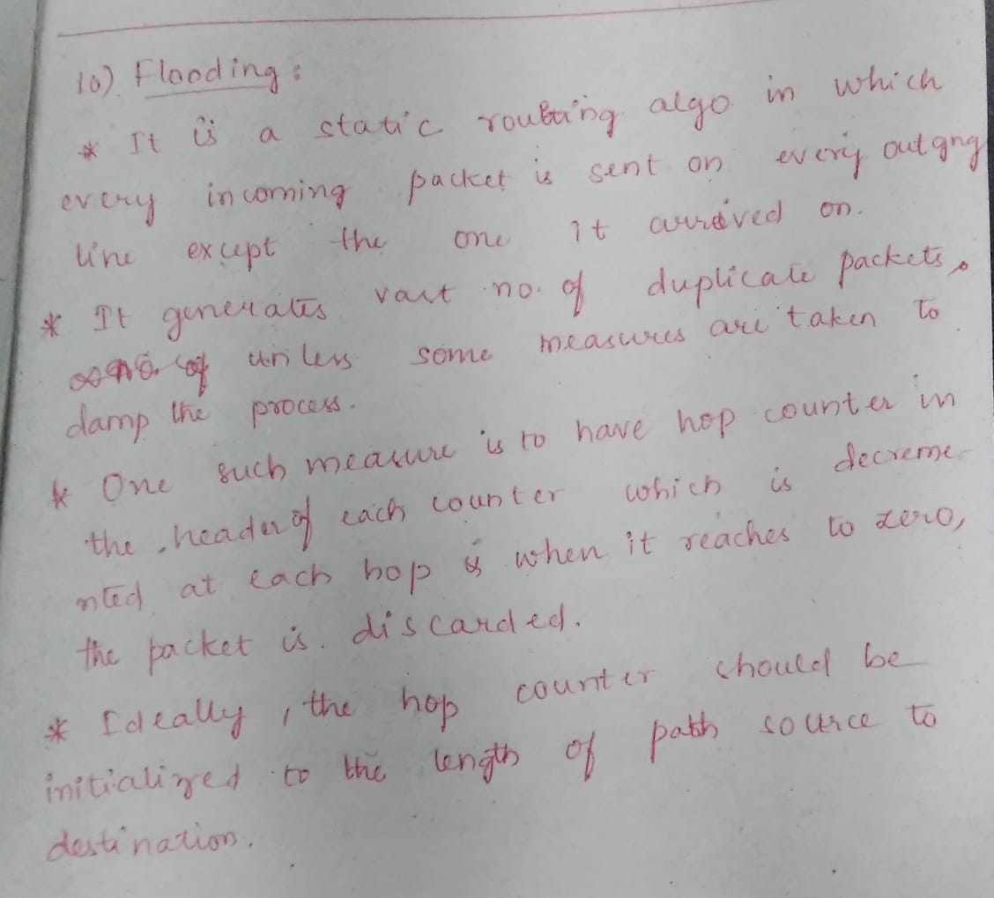

Long Answer Questions
1 | Differentiate between LAN, MAN and WAN.
2 | Compare and contrast the OSI and TCP/IP reference models
3 | Discuss about the various transmission media available at the physical layer.
4 | Elaborate on mobile telephone system.
5 | Explain about Go Back N Sliding Window Protocol.
6 | Explain about channel allocation problems.
7 | What are the different types of error detection methods? Explain the CRC error  detection technique using generator polynomial x4+x3+1 and data 11100011.
8 | Explain Byte Stuffing and Bit Stuffing?
9 | Discuss about Network layer design issues.
10 | With an example, explain shortest path routing.

11 | Explain the ISO-OSI model of computer network with a neat diagram.
12 | Explain any three types of Wireless Transmission Media.
13 | Describe briefly Connection Oriented X.25 and Frame Relay.
14 | Demonstrate Hamming Code with an Example
15 | What is the purpose of CSMA CD? And Explain it.
16 | Explain and demonstrate Selective repeat sliding window Protocol with an example.
17 | Write short notes on Wireless Transmission.
18 | Explain Bluetooth Architecture in detail.
19 | What are the advantages of adaptive routing approach over non adaptive routing?
20 | The major problem with distance vector algorithm is ‘count to infinity’. How exchange of complete path from router to destination instead of delay helps solve the count to infinity problem.

